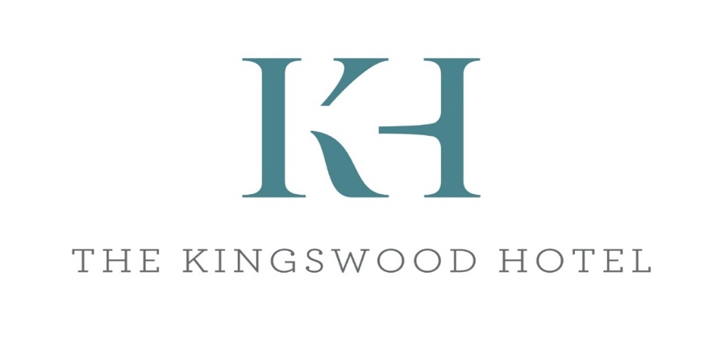
Afternoon tea
Sample menu

Selection of ribbon sandwiches
Devon ham & English mustard
Roast beef & horseradish
Somerset cheddar & apple cider chutney
Coronation chickpea, vegan mayo & sultanas
Free range egg mayonnaise
Tuna mayonnaise

Devon Cream Tea
Freshly baked plain or fruit scones, selection of jams & Devon clotted cream

Sample Cake selection
Chocolate Brownie (GF)
Yoghurt topped raspberry flapjack
Lemon drizzle cake

Clipper Organic Breakfast tea
Premium filter Coffee

£15.00 per person
Please let us know of an allergies or intolerance. Gluten free & Vegan options available upon booking
Please note this is a sample menu, prices & dishes are subject to change
Bookings under 25 persons are subject to a room hire fee

