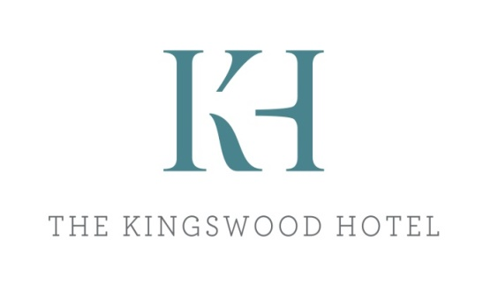

Three Course Menu
*Sample*

Starters
Homemade soup of the day - vg
River Fowey mussels, white wine garlic cream, sourdough
Chicken Caesar salad, baby gem, parmesan, caesar dressing - gf
Portobello mushroom, welsh rarebit, wild rocket, tomato pesto – v

Main Courses
Steak & ale pie, short crust pastry, creamed potatoes, beef stock jus
Grilled seabass fillet, steamed rice, coconut cream & sweet chilli sauce
Oven baked corn fed chicken breast, fondant potato, white wine & tarragon sauce
Mediterranean vegetable & red wine linguini Bolognese - vg

Desserts
Banoffee pie, chantilly cream – v
Summer berry crumble, custard – v
Eton mess sundae, meringue pieces, strawberry compote, vanilla ice cream, clotted cream - vg

Westcountry Dairy ice cream selection (gf)
Clotted cream vanilla, double chocolate, mint choc chunk, honeycomb
Yarde farm plant-based ice cream – Vanilla, Chocolate - vg

A selection of West Country cheese & biscuits
Barbers cheddar, Somerset brie, Dorset blue, rustic biscuits, Devon chutney

Two courses £25 / Three courses £30

Please note this is a sample menu, prices & dishes are subject to change
If you have any allergies or dietary requirements, please speak to a member of staff before ordering
vg = vegan or vegan alternative available – v = vegetarian – gf = gluten free or gluten free option available

